Affordable Housing Mass Mailings

Open Affordable Housing COAH Database

Right Click on Base Query and select Design View

Enter desired criteria

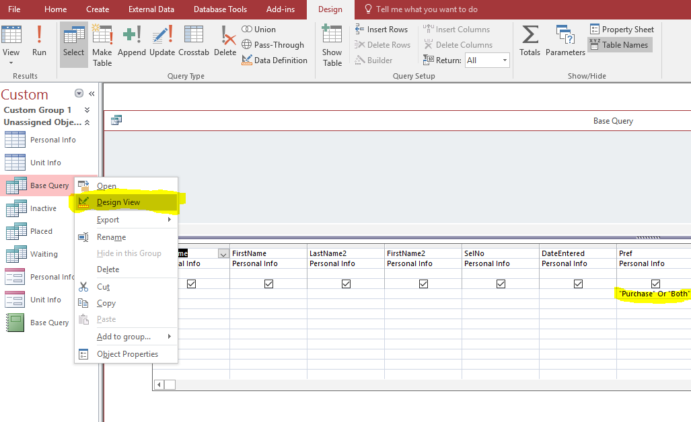

Click Run on the Design View tab

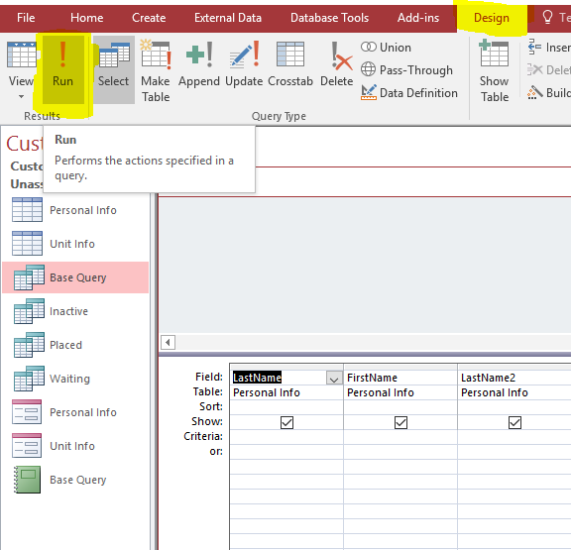

This will bring up the randomized results based on the specified criteria

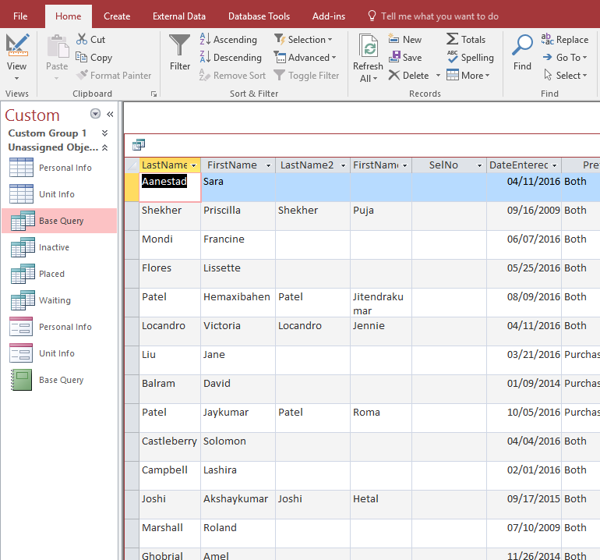

Right click the box in the upper left hand corner and select Copy

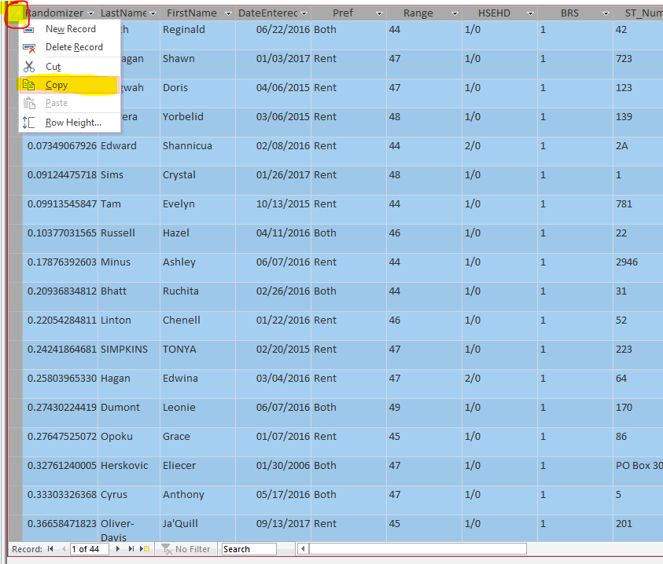

Close out.
Will ask you
Do you want to save changes- yes
Do you want to copy to the clipboard – no

Open Excel spreadsheet named Master Recipient List. Right click on the column-heading cell named Randomizer and click the clipboard and paper icon under Paste Options. This will insert the copied data from the query while maintaining the format of the Excel spreadsheet
Make sure to use the Save As option to save the spreadsheet as a different name so that the Master Spreadsheet is not overwritten
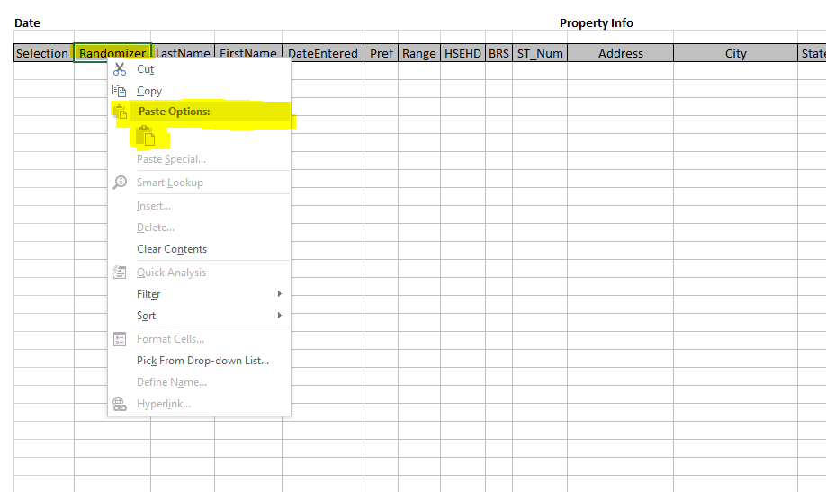

In the Selection column (A) type 1 in the 2nd row and type 2 in the 3rd row then select both of those cells (A2 & A3)

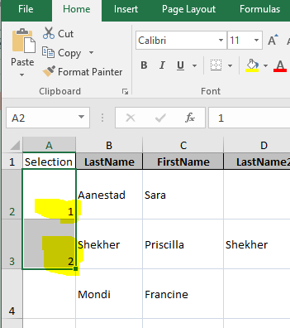

Left click on the bottom right corner of the two selected cells

Drag the selection all the way down to the last entry

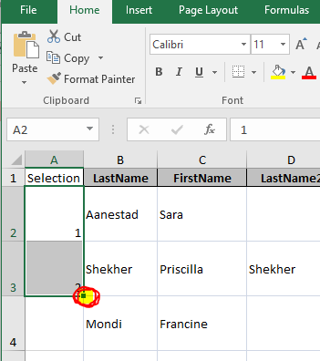

This will sequentially number all of the randomized results

At this point save the Excel spreadsheet and print for records

If no further notes need to be made the Excel spreadsheet can be closed

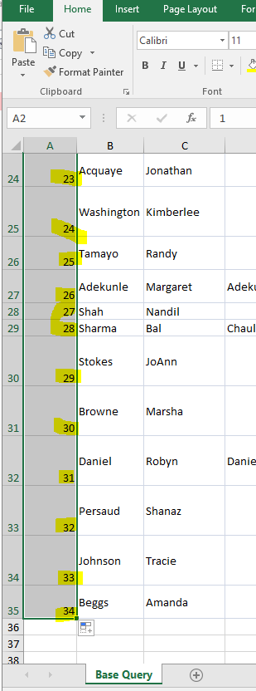
To Insert an individual record later, first choose where you want to place the record. Then, right click the row below it, choose Insert and fill out the corresponding information in the new blank row

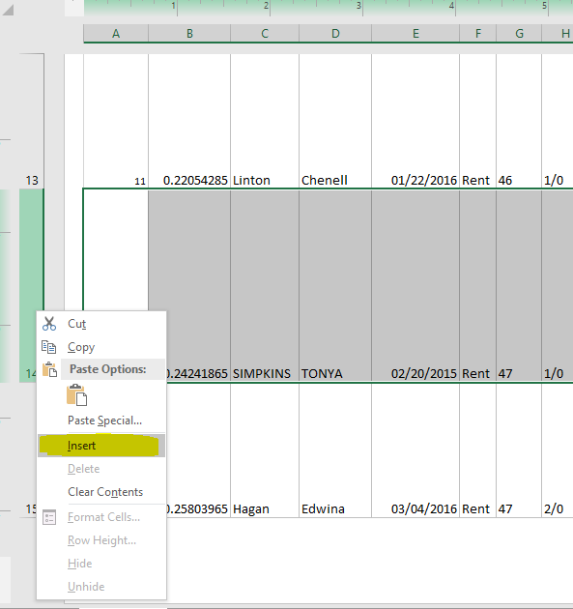

Next, open the Master letter for the property and make any necessary changes to the text
*Be careful not to save changes over the Master letter. Always do Save As… to give the letter a new name if you want to save a copy

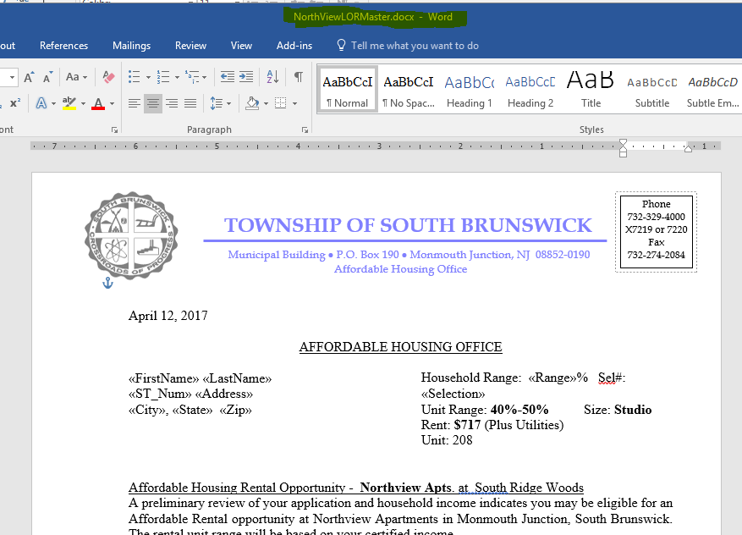

When ready to start the Mail Merge, under the Mailings tab, choose Start Mail Merge and Step-by-Step Mail Merge Wizard…

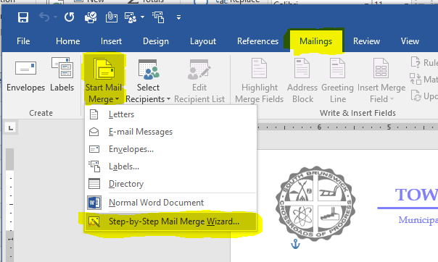

The Mail Merge wizard should open on the right side of the letter

Choose Next until Step 3

Select Use an existing list and click Browse… to open the saved Excel spreadsheet from earlier

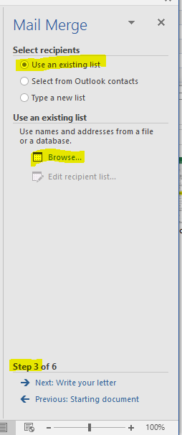

Click OK

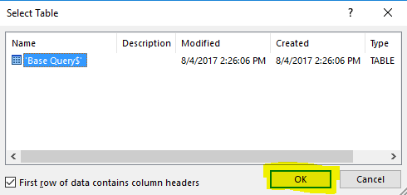

At this step, you can use the check box to unselect any entries. Once all the entries are correct click OK
*Clicking any of the column names will reorganize the results
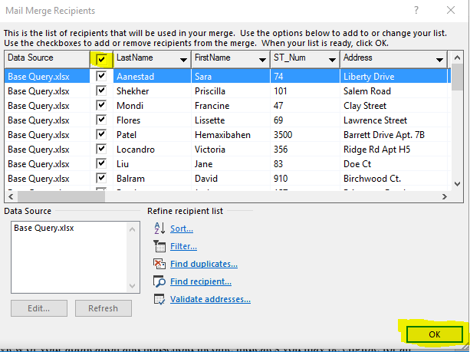
Click Next on the Mail Merge wizard until Step 5

At this step, you can review the recipients by clicking the forward or backward arrows

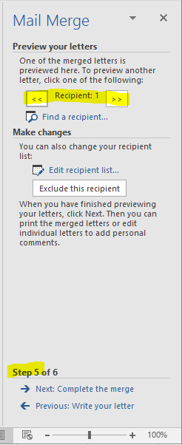

The Name, Address, Household Range, and Sel# should correspond with the Excel spreadsheet

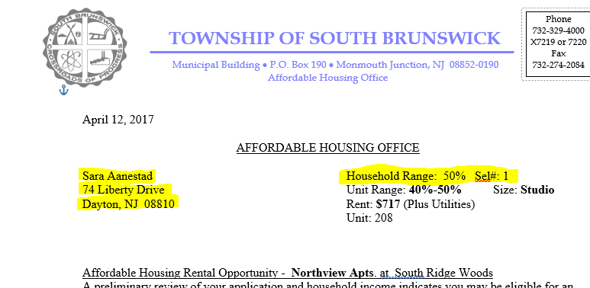

Click Next: Complete the merge on the Mail Merge wizard

Now the letters can be printed and the document can be closed
*If needed, choose Save As… to save this set of letters so the Master letter doesn’t get written over

